- Framing
Framing is a function of the data link layer. It provides a way for a sender to transmit a set of bits that are meaningful to the receiver.
Ethernet, token ring, frame relay, and other data link layer technologies have their own frame structures.
Frames have headers that contain information such as error-checking codes.
Framing in the data link layer separates a message from one source to a destination, or from other messages to other destinations, by adding a sender address and a destination address. The destination address defines where the packet is to go; the sender address helps the recipient acknowledge the receipt.
Normally the whole message is divided into different frames to make flow and error control efficient. (When a message is carried in one very large frame, even a single-bit error would require the retransmission of the whole message. When a message is divided into smaller frames, a single-bit error affects only that small frame.)
  - Fixed-Size Framing
Frames can be of fixed or variable size. In fixed-size framing, there is no need for defining the boundaries of the frames; the size itself can be used as a delimiter.
Example: the ATM wide-area network- It uses frames of fixed size called cells.
  - Variable-Size Framing
In variable-size framing, we need a way to define the end of the frame and the beginning of the next. Two approaches were used for this purpose:
- a character-oriented approach and
- a bit-oriented approach.
Character-Oriented Protocols
In a character-oriented protocol, data to be carried are 8-bit characters from a coding system such as ASCII.
The header and trailer are also multiples of 8 bits.(The header normally carries the source and destination addresses and other control information. The trailer carries error detection or error correction redundant bits)
To separate one frame from the next, an 8-bit flag is added at the beginning and the end of a frame. ( The flag composed of protocol-dependent special characters).
The flag signals the start or end of a frame.
Any pattern used for the flag could also be part of the information, to fix this problem a
byte-stuffing strategy was added to character-oriented framing.
In byte stuffing (or character stuffing), a special byte is added to the data section of the frame when there is a character with the same pattern as the flag. The data section is stuffed with an extra byte. This byte is usually called the escape character (ESC), which has a predefined bit pattern.
Whenever the receiver encounters the ESC character, it removes it from the data section and treats the next character as data, not a delimiting flag.
(Byte stuffing by the escape character allows the presence of the flag in the data section
of the frame, but it creates another problem. If the text contains one or more escape characters followed by a flag? The receiver removes the escape character, but keeps the flag, which is incorrectly interpreted as the end of the frame. To solve this problem, the escape characters that are part of the text must also be marked by another escape character. In other words, if the escape character is part of the text, an extra one is added to show that the second one is part of the text.)
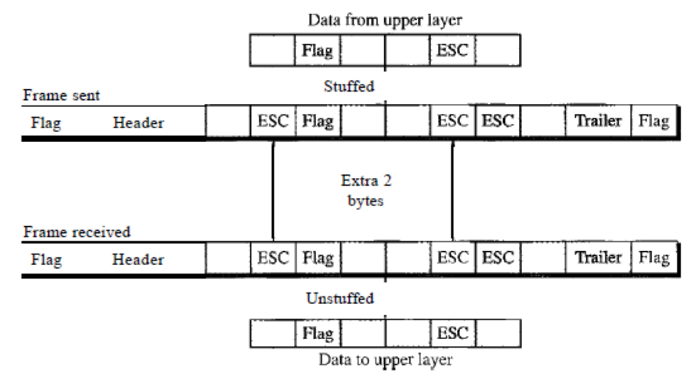
Another problem with character-oriented protocols : coding systems in use today, such as Unicode, have 16-bit and 32-bit characters that conflict with 8-bit characters.
Bit-Oriented Protocols
In a bit-oriented protocol, the data section of a frame is a sequence of bits to be interpreted by the upper layer as text, graphic, audio, video, and so on.
Most protocols use a special 8-bit pattern flag 01111110 as the delimiter to define the beginning and the end of the frame.
If the flag pattern appears in the data, we use bit stuffing to prevent it from looks like the end of the frame.
In bit stuffing, if a 0 and five consecutive 1 bits are encountered, an extra 0 is added. This extra stuffed bit is eventually removed from the data by the receiver.
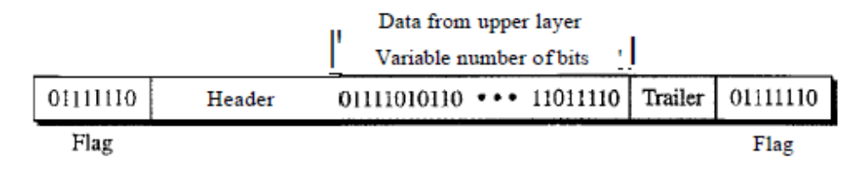
This ensures nowhere in the data we have a pattern of 6 consecutive ones after 0. In data regardless of the value of the sixth bit , after zero and five consecutive ones the next bit will be stuffed with a zero bit. The pattern of zero, six consecutive ones and zero (01111110) thus appears only in the flag.
- Flow Control
For reliable and efficient data communication a great deal of coordination is necessary between two machines, because of the following constraints:
- Both sender and receiver have limited speed
- Both sender and receiver have limited memory

It is one of the most important duties of the data link layer.
Flow Control is a technique so that transmitter and receiver with different speed characteristics can communicate with each other.
In most protocols, flow control is a set of procedures that tells the sender how much data it can transmit before it must wait for an acknowledgment from the receiver.
Any receiving device has a limited speed at which it can process incoming data and a limited amount of memory in which to store incoming data. The receiving device must be able to inform the sending device before those limits are reached and to request that the transmitting device send fewer frames or stop temporarily.
Incoming data must be checked and processed before they can be used. The rate of such processing is often slower than the rate of transmission. For this reason, each receiving device has a block of memory, called a buffer, reserved for storing incoming data until they are processed. If the buffer begins to fill up, the receiver must be able to tell the sender to halt transmission.

- Error Control
If error occur during transmission, it is necessary to devise mechanism to correct it.
Error Control involves both error detection and error correction.
When an error is detected, the receiver can have the specified frame retransmitted by the sender. This process is commonly known as Automatic Repeat Request (ARQ). Error control is both error detection and error correction. It allows the receiver to inform the sender of any frames lost or damaged in transmission and coordinates the retransmission of those frames by the sender.

